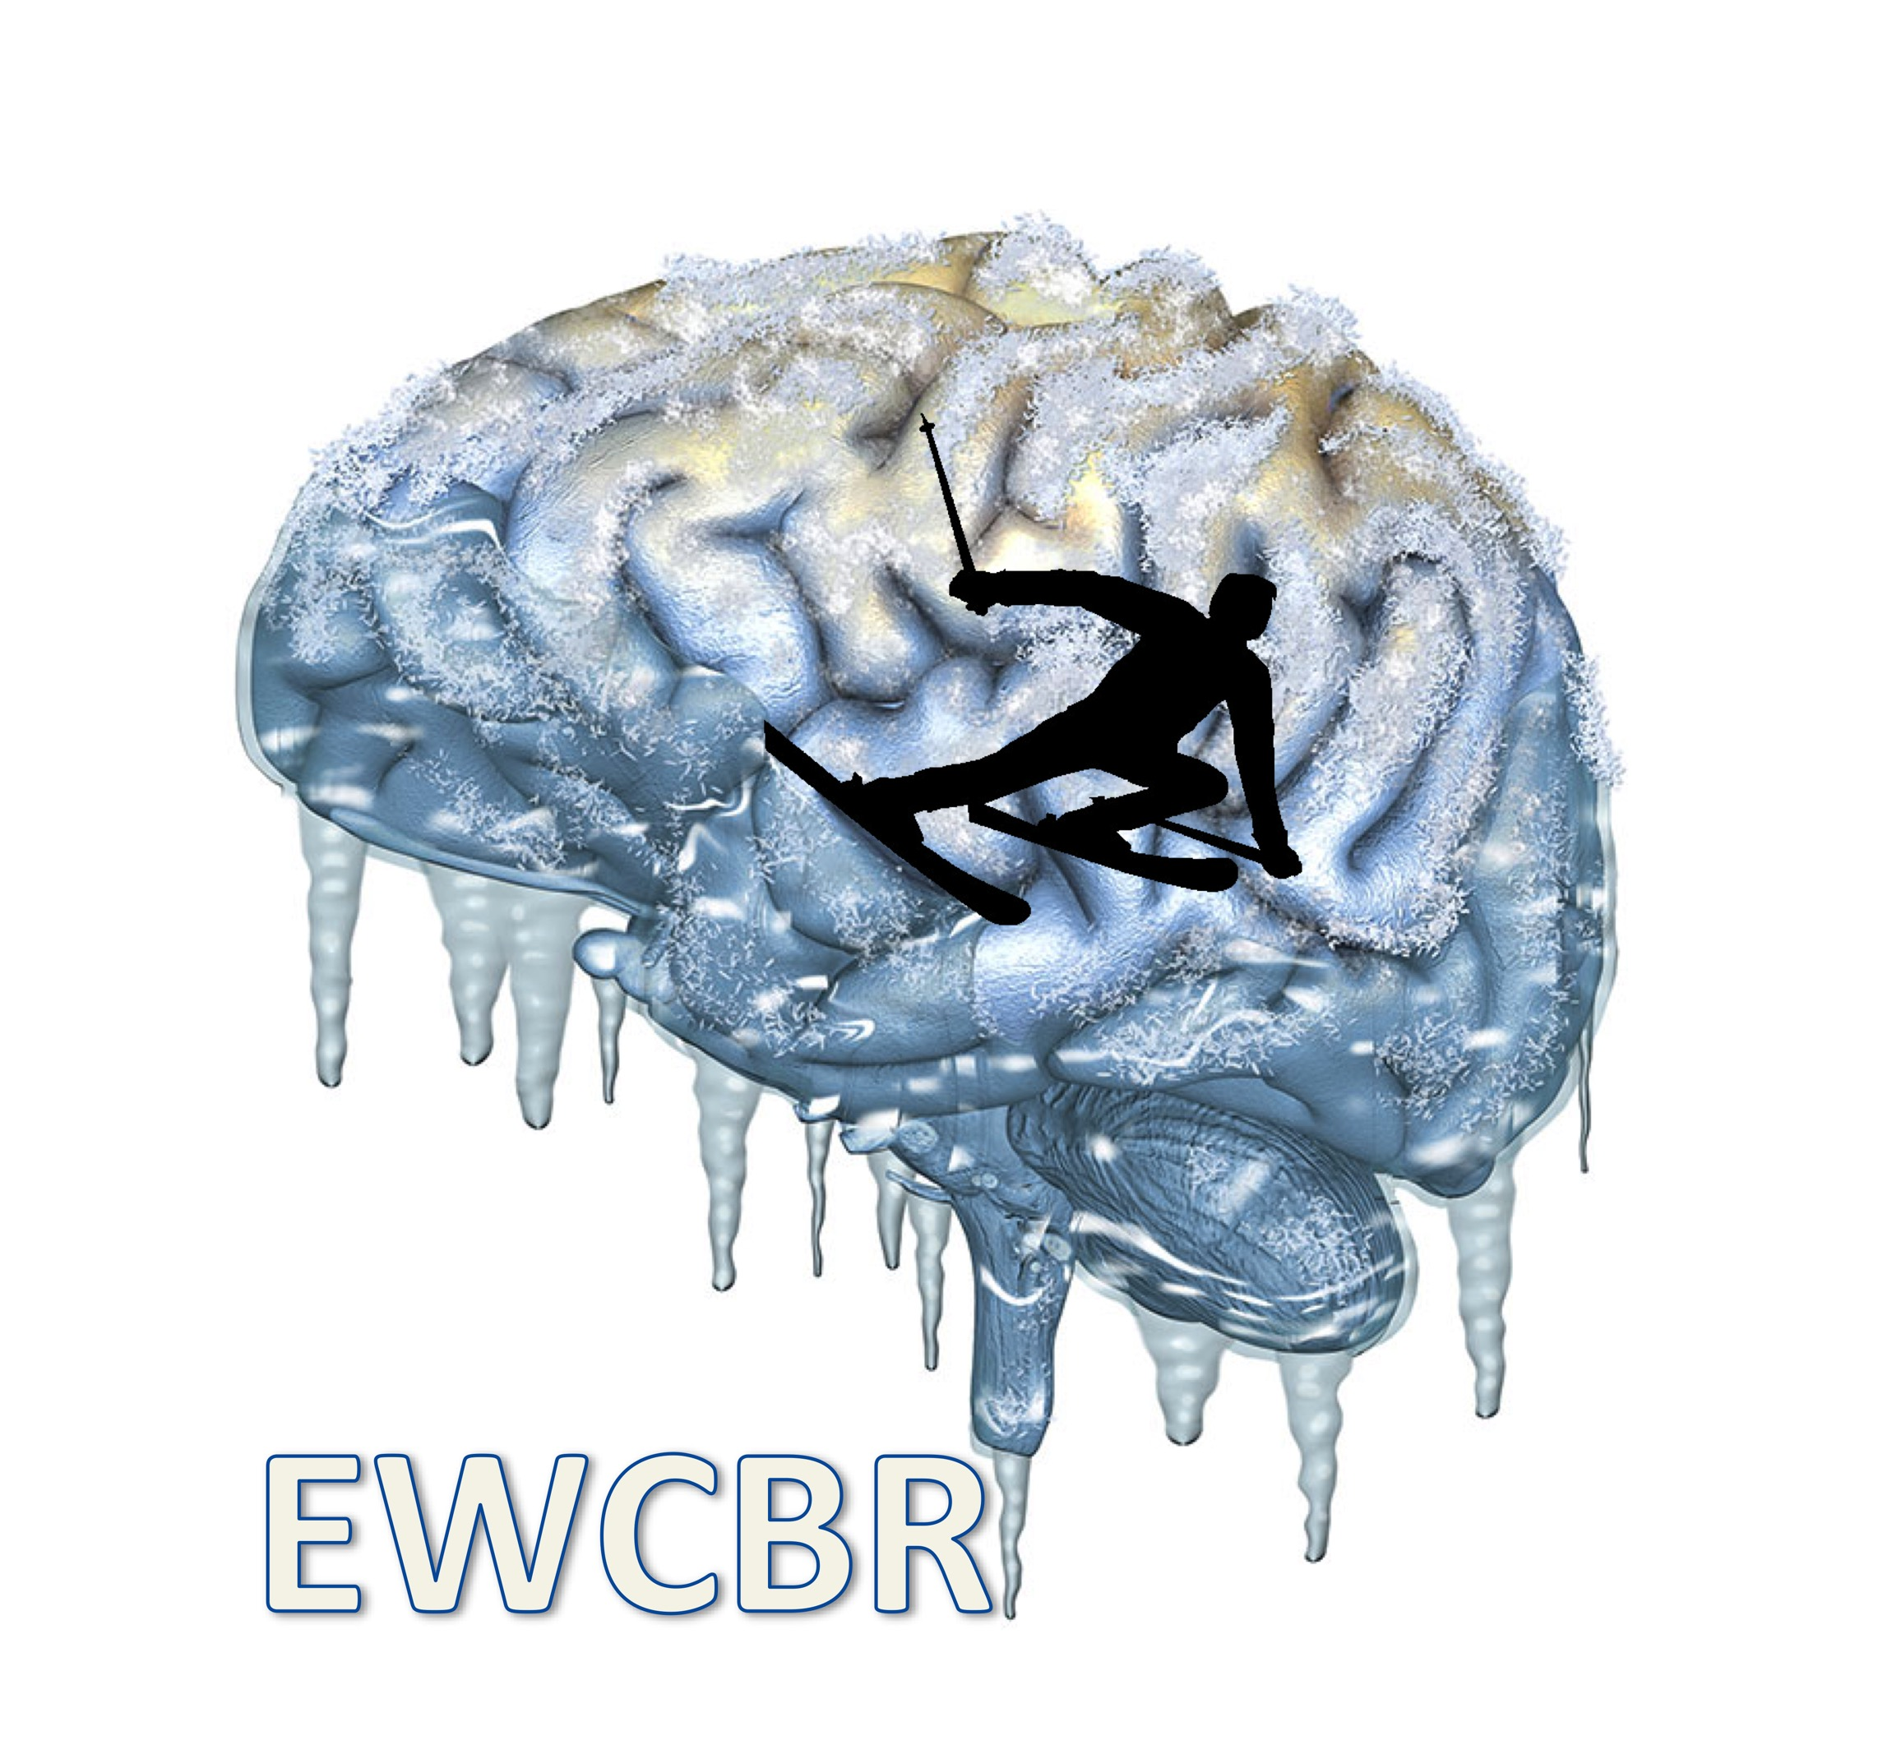**EWCBR 2023 / REGISTRATION AND ACCOMMODATION FORM**

**4 – 11 MARCH 2023**

**REGISTRATION FORM**

To be sent by mail to: [ewcbr2017@gmail.com](mailto:ewcbr2017@gmail.com)

NAME: FIRST NAME:

INSTITUTION:

CITY: COUNTRY:

TELEPHONE: E-MAIL:

**A) REGISTRATION FEES**

‐ Payment from Institutions or Universities 260€

after Jan 31st 2023 300€

‐ Others (pharmaceutical companies...) 400€

after Jan 31st 2023 450€

‐ Junior scientist invited in a session 50€

‐ Accompanying person 50€

**TOTAL A= €**

**B) ACCOMMODATION:**

Ο I wish to have a private room

Ο I wish to share a double room with (please indicate)**:………..

***\*\* Only for participants arriving and leaving on the same dates with simultaneous payments. We do not organize the sharing, so get organized with your room mate***

Accommodation at **Eurotel, Les Diablerets Switzerland**:

Priority will be given to those booking the entire package including 7 nights.

The package (from dinner March 4th to breakfast March 11th) includes complete

hotel services and half- board (breakfast and dinner).

Package for the entire meeting:

O **Double room: 1 015€/person** or ........x 145€/night# + 15€ (booking and admin fees)##

O **Single room: 1 225€** or ........x 175€/night# + 15€ (booking and admin fees)##

***#If you do not book the entire package, please indicate your exact dates of arrival and departure:***

***##: only add the 15€ admin fee if you do not book the entire package***

**TOTAL B = €**

**TOTAL A+B = €**

• PAYMENT BY CHECK (French participants and from Euro Zone countries): to PROMOTION DES NEUROSCIENCES EUROPEENNES

to be sent to C. Baunez, Promotion des neurosciences européennes, 8 traverse Fontaine de Caylus 13002 Marseille, France.

• PAYMENT BY BANK TRANSFER (others): to the following bank account: B.N.P. (BANQUE NATIONALE DE PARIS) Agence St Ferreol, Rue St Ferréol, 13001 Marseille

Account no. 30004**‐**01841**‐**00005317896**‐**83. (EUROCHECKS WILL NOT BE ACCEPTED)

IBAN: FR76 3000 4018 4100 0053 1789 683

**IMPORTANT: MAKE SURE YOUR NAME APPEARS ON THE BANK TRANSFER AND SELECT THE OPTION TO PAY YOURSELF FOR THE TRANSFER FEES**

**NEW! PAYMENT By PAYPAL is possible but will imply fees to be paid cash onsite. Email address to use:** [**ewcbr2017@gmail.com**](mailto:ewcbr2017@gmail.com) **, please contact treasurer before proceeding (**[**christelle.baunez@univ-amu.fr**](mailto:christelle.baunez@univ-amu.fr) **or** [**ewcbr2017@gmail.com**](mailto:ewcbr2017@gmail.com) **)**

Notes: Be aware that cancellation of booking will lead to only partial reimbursement, as we have to pay the hotel in advance.