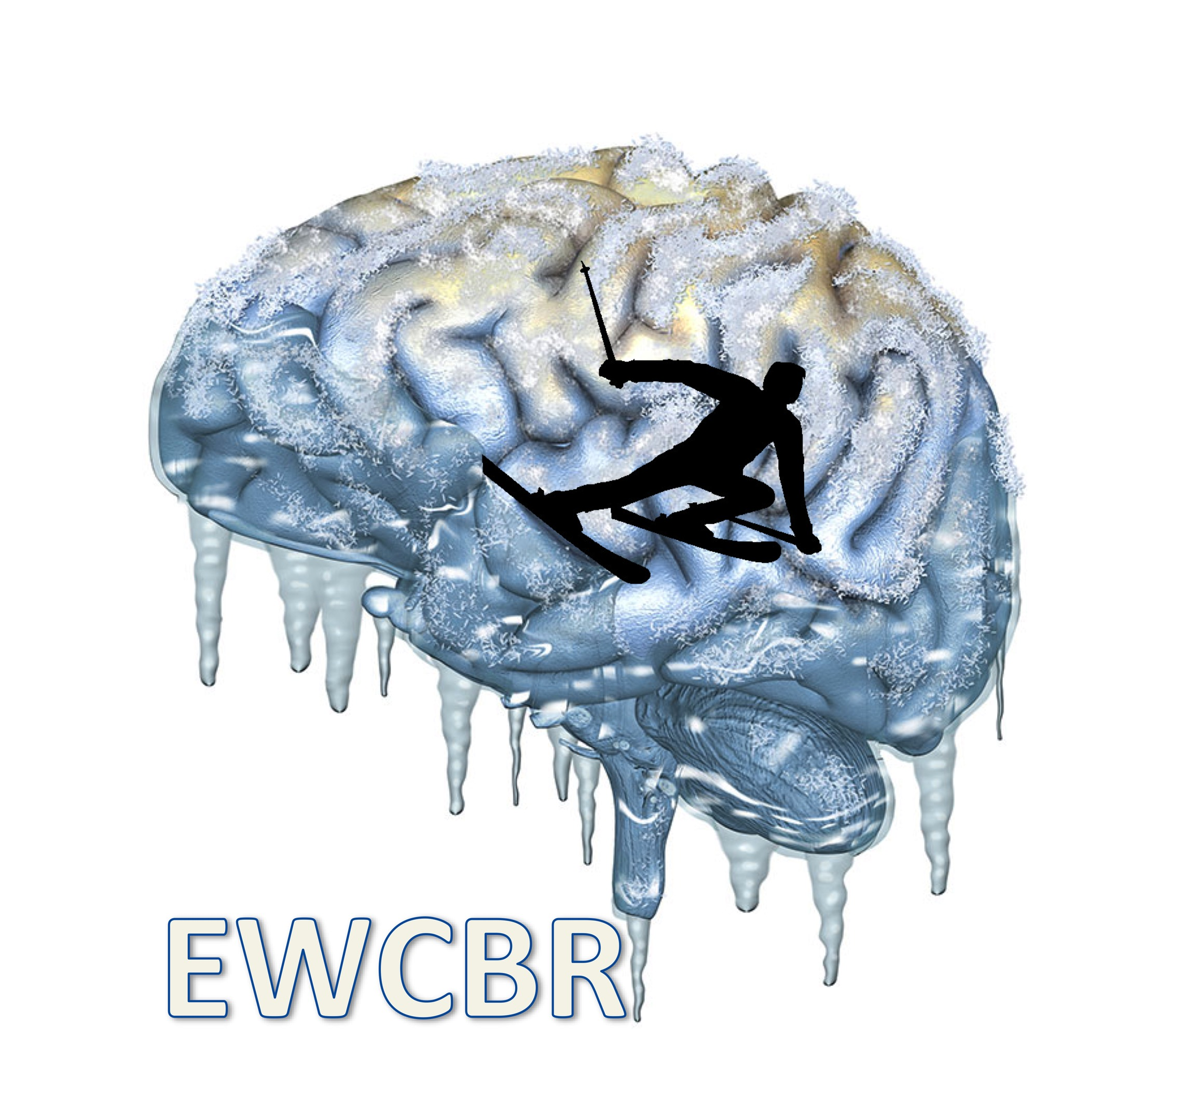

**EUROPEAN WINTER CONFERENCE ON BRAIN RESEARCH**

**41th E.W.C.B.R. / E.B.B.S WINTER CONFERENCE**

**Switzerland, Eurotel, Les Diablerets**

**March 4th – March 11th, 2023**

**SYMPOSIUM PROPOSAL**

non-preferred congress days (to be avoided) for the symposium

Monday 6th : [   ]

Tuesday 7th : [   ]

Wednesday 8th : [   ]

Thursday 9th : [   ]

Friday 10th : [   ]

Title of the symposium:

Organizer () :

Email:

Chair(s) :

Email:

Speaker 1, Title, Institution, Title of the talk

Email:

Abstract:

Speaker 2, Title, Institution, Title of the talk

Email:

Abstract:

Speaker 3, Title, Institution, Title of the talk

Email:

Abstract:

Speaker 4, Title, Institution, Title of the talk

Email:

Abstract: